Algorithm for file updates in Python

Project description
[This project involves developing a Python algorithm for a healthcare company's security team to manage access to restricted patient records. The algorithm will check for unauthorized access by comparing an allowed list of IP addresses permitted to access a restricted subnetwork against a removed list of IPs that should no longer have access. It also requires identifying and removing any IP addresses from the allow list that appear in the remove list, and ensuring the allow list is properly maintained by modifying the file accordingly. This helps maintain secure access controls by ensuring only authorized employees can access restricted content.]

Open the file that contains the allow list
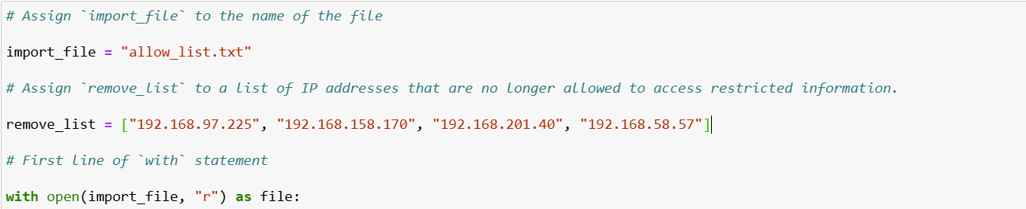[The Python syntaxes needed to accomplish opening the file that contains the allow list, are variables, with, open(), and as. First, when importing a .txt file, it is important to assign a variable to it in order to work on it inside Python. In this case, I assigned a variable named import_file, to know that this variable will be used to import the allow_list.txt file. Then, a with statement is used to open the file and handle the external file to bring into Python. To open the file, the open() function was used to specify the file that we will open and what we will do with the file. In this case, we want to read the contents in the file, so the first argument to pass through the open() function is the import_file containing the allow_list.txt file, and then “r” for reading the file. Then, to store the file inside Python while I worked on it, I used as file, to store the import_file as the variable file, to allow me to work on the file in Python.

Read the file contents
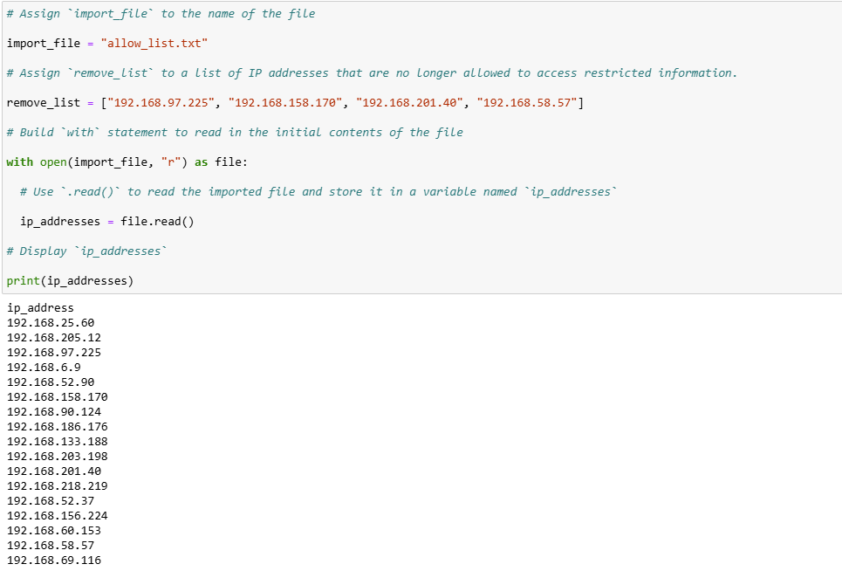
[Now, to be able to see the contents within the file, the next steps are to use the .read() method to convert the contents of the allow list file into string data so that we can read them within Python. These string data will then be stored in another variable labeled ip_addresses, to be able to output the contents within the file using the print() method and pass through ip_addresses. As shown above, the output shows the list of IP addresses, which are in string format.]

Convert the string into a list

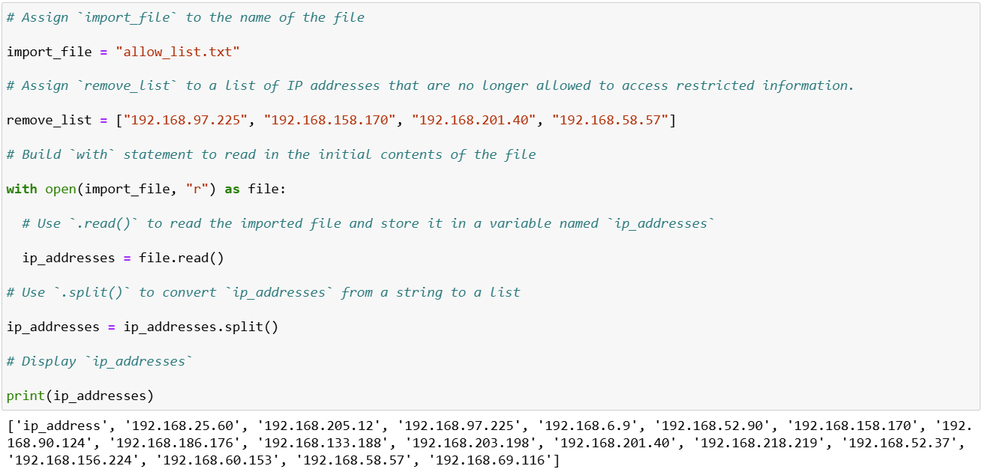
[To make it easier to work with the dataset inside the file, I parsed the variable ip_addresses into a list data. Once the data is parsed into list data, this will allow me to use functions for removing unwanted IP addresses easier through Python. To parse the file, I used the function split() on the variable to split the string data into a list data. The parenthesis inside the split() specifies a string character on where to split the data. In this case, since there isn’t a specified string character like a comma, I left the argument blank for Python to split the data every time it encounters whitespace, which in this case is returns for new lines. I then updated the variable ip_addresses, then printed it to check if the data returns as a list data. In the output above, it shows that the data is now outputted as a list, with brackets and commas separating each of the IP addresses.]

Iterate through the remove list
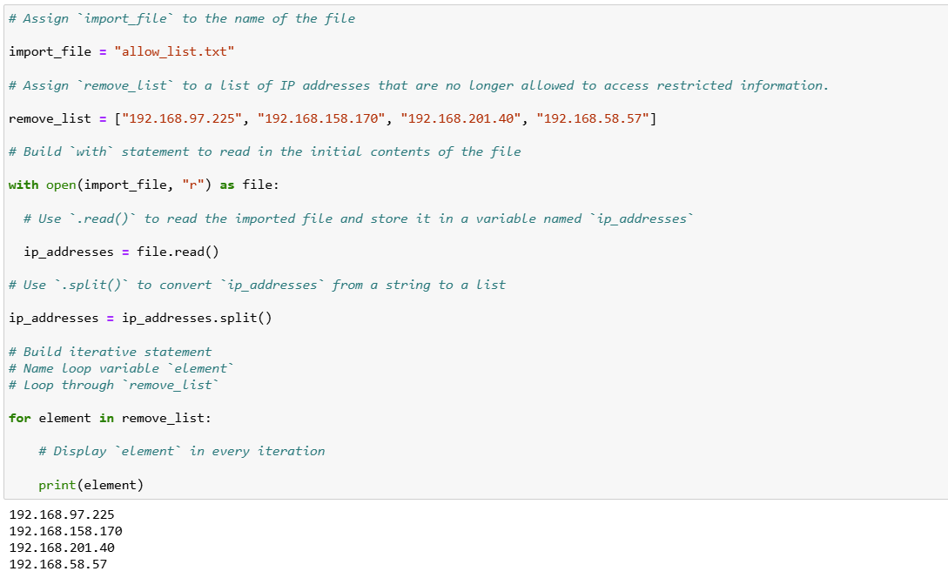

[Now that the string data is converted into a list data, I could now start an iterative statement that would check each of the IP addresses, and see if it matches any of the IP addresses that was listed under remove_list. I achieved this through using a for loop to cycle through the remove_list and store the loop into a variable under element. I printed out the iterative statement, and it did loop through each of the IP addresses listed under remove_list and output each of the IP addresses listed.]

Remove IP addresses that are on the remove list
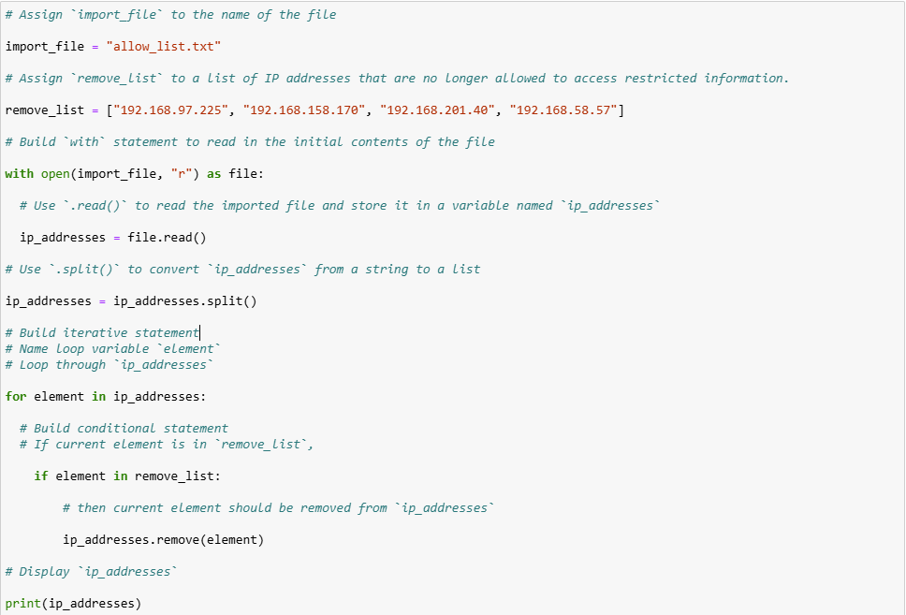
[Now that the iterative statement has been tested, I could then move forward to removing the IP addresses in the ip_addresses list that match with the remove_list IP addresses. To continue building out the iterative statement, I included a conditional statement with an if statement, and described if the current element in ip_addresses, had any of the IP addresses listed in remove_list, then it would remove the current element within the ip_addresses list, using the .remove() method that passes through the element variable. It would then scan the next element and loop through the end of the ip_addresses list. I then printed the ip_addresses list to check if Python had removed the unwanted IP addresses, and the output shows none of the unwanted IP addresses in its list. Applying the .remove() in this way was possible because there were no duplicate IP addresses in the ip_addresses list.]

Update the file with the revised list of IP addresses
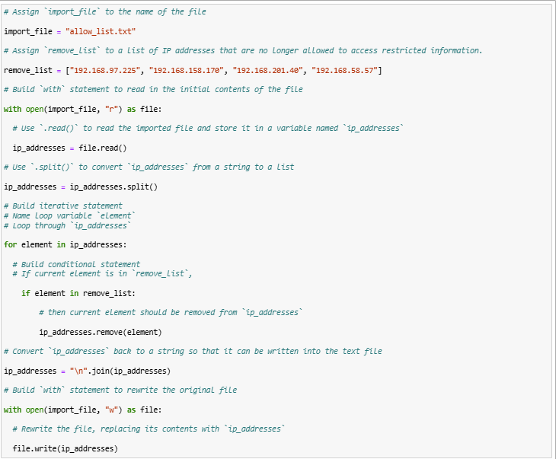
[Now that I was able to remove the unwanted IP address from the ip_addresses list, I had to update the allow_list.txt file and make sure that the list data is converted back to string, so that it can be written into the text file. To do this, I converted the ip_addresses variable to string using the .join() option, and passed through the ip_addresses variable, so that it can convert the list data back into string. I then specified the string “\n” to separate the elements in the file by new lines to show it as a list of strings. I then used the with open() as file command like the beginning of the code, but this time, the second argument is “w” for write, which will specify that I will write over the original file and update it with the IP addresses that were removed. Then, I used the.write() option on the file variable, and passed through the ip_addresses variable inside the option, to replace the contents inside.]

Summary
[I was able to complete this project and develop an algorithm in Python to remove unwanted IP addresses that should not access restricted patient records, to a list of allowed IP addresses. This was achieved through opening and parsing the file that contained the list of allowed IP addresses within Python, converting the string data into list data to work with the list of IP addresses inside, and using the data to create an iterative statement to check for the allowed IP addresses. Then, I built a conditional statement within the iterative statement that checked if each of the elements inside the allowed IP address list matched with the unallowed IP addresses, and if it did, it would remove those IP addresses from the allowed IP list. Then, I converted the list data back into string data, and updated the allowed IP address, so that the text file has an updated list of IP addresses that were filtered through Python.]

